# BIOL 708 - QMEE Final Report

*Mercury in fish from the Saint John River*

**Instructors:** Ben Bolker, Jonathan Dushoff

**Prepared by:** Jenni Velichka, Kaiying Sally Ju (Poisson gals)

April 28, 2021

# Contents

1Introduction 3

Background information 3

Scientific questions 4

Methods 4

Scientific methods 4

Statistical methods 5

Statistical analyses 5

Summarizing Fish Size 5

Developing a Linear mixed-effects model 8

Results of the Linear mixed-effects model 10

Discussion 13

Literature Cited 15

**Appendix A: Supplementary Figures** 16

## Introduction

### Background information

Mercury (Hg) is a pollutant of global concern. Although it occurs naturally, anthropogenic emissions have increased its release into the atmosphere, where it may travel from the point of release until it is deposited on land or water. A key link between Hg emissions and human exposure occurs in aquatic ecosystems; here, inorganic Hg can be converted to the more toxic form of Hg, methylmercury (MeHg) (Driscoll et al. 2013). MeHg is a bioaccumulating neurotoxin that can become elevated in top predators in aquatic systems which can have negative effects on fish consumers. Fish specifically provide significant nutritional value and are often an important traditional food for Indigenous populations. However, the risks from elevated MeHg can undermine the health benefits of fish consumption and put communities at risk.

Furthermore, human alteration of aquatic systems can impact Hg concentrations in the water. For example, dams in rivers create large reservoirs of flooded soils, which mobilizes previously sequestered Hg and changes Hg speciation due to increased bacterial methylation of inorganic Hg (Bodaly et al. 2007; Bilodeau et al. 2016). In turn, this increases MeHg in the water and its bioaccumulation in top predators, including fish (Bodaly et al. 2007). Furthermore, Hg levels in fish are shown to increase with fish length and position in the food web (Storelli et al. 2006; Ouédraogo et al. 2015); therefore, various variables should be considered when creating fish consumption advisories. This study will determine the risks of elevated MeHg production due to the construction of the Mactaquac Generating System (MGS), a hydroelectric dam located on the Saint John River (SJR). The SJR is the second longest river in Northeastern North America and supports the subsistence fisheries of six First Nation communities. Previous studies have reported high levels of Hg in fish from this river (Reinhart et al. 2018a and b), however, this study will provide a more thorough understanding of the risks associated with consuming fish from various locations along the SJR.

### Scientific questions

This study will compare two fish species that vary in their trophic position: Smallmouth Bass (SMB; *Micropterus dolomieu*) and Yellow Perch (YP; *Perca flavescens*). We will also compare Hg in the site upstream to the dam (REF), to two sites downstream of the dam (NF, FF). Comparisons between species and sites will be used to answer the following questions: 1) how does Hg concentration increase with fish size and; 2) how does Hg concentration vary in fish from upstream versus downstream of the dam? To answer the first question, we aim to combine various physical measurements of the fish to describe fish size using a single parameter. A linear mixed effects model will be used to compare the relationship of Hg to size, sex, and site in each species.

## Methods

### Scientific methods

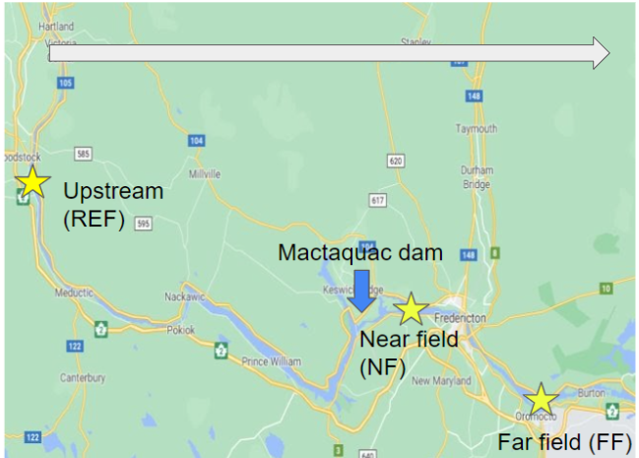

**Figure 1.** Map of the 3 sites relative to the location of the Mactaquac dam. The white arrow signifies the direction of the river flow from upstream to downstream.

Two fish species were targeted for this study: Smallmouth Bass and Yellow Perch. Fifty fish (25 male and 25 female) of each species were targeted using boat electrofishing at each of three sites relative to the MGS: one upstream referred to as Reference (REF), and two downstream referred to as Near Field (NF) and Far Field (FF) (Figure 1). No SMB were caught at the FF site as we were unsuccessful at catching them via boat electrofishing. The fish were kept frozen for transportation from the field to the lab. In the lab, fish were measured and dissected for total length, fork length, total weight, liver weight, and gonad weight. Furthermore, muscle tissue was dissected and flash-frozen on dry ice for later analysis.

Fish samples were transported back to McMaster University, and stored at -80°C until further analysis. Samples of fish tissue were freeze-dried, homogenized and analyzed for total mercury (THg) concentration using a Tricel DMA-80 Direct Mercury Analyzer. THg is an appropriate measure of MeHg for fish as the form of Hg in fish muscle tissue is typically >95% MeHg (Bloom, 1992; Francesconi and Lenanton, 1992). All THg concentrations were recorded in μg of Hg per kg of muscle tissue (wet weight), which was calculated using the percent moisture of the fish.

### Statistical methods

All statistical tests were completed in R version 4.0.4. First, the number of predictor variables were reduced because we expected that the physical parameters measured in the fish to be correlated. This was completed by using a principal component analysis (PCA) using the packages *FactoMineR* and *factoextra* for the analysis, coordinates, contributions, and figures. The biplot figures produced from the PCA were used to visualize relationships between the parameters, and the results also summarize and combine the correlated physical variables. Next, a linear mixed-effects model was completed to test whether mercury increases with increasing fish size. Diagnostic plots for the linear mixed-effects model were completed using the *DHARMa* package, and the model was completed using *lme4* and *lmerTest* packages. Effects plots for the linear mixed-effects models were completed using the *effects* packages to determine the relationship between Hg and size and compare the differences in Hg between sites and sex in YP and SMB.

## Statistical analyses

### Summarizing Fish Size

First, a PCA was used to summarize the correlated physical parameters which were measured for the fish. These variables are total and fork length, total weight, liver weight, and gonad weight.

#### PCA of fish size with both species

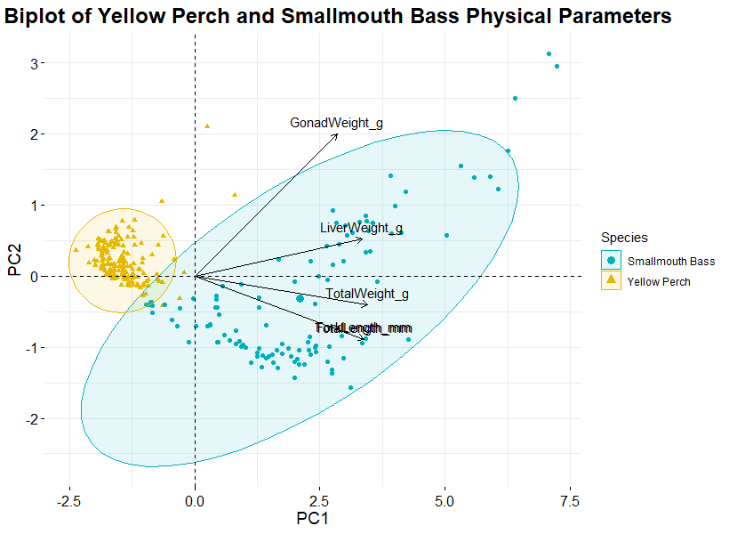

**Figure 2.** The PCA biplot of the physical parameters (fork length (mm), total length (mm), total weight (g), liver weight (g) and gonad weight (g)) in the fish showing the loading of each parameter (arrows) and the scores of each fish (points). 95% bivariate ellipses are given for both species. Principal component 1 (PC1) explains 87.7% of the variability in the physical variables while principal component 2 (PC2) explains 9.6%. Physical parameters are indicated by the arrows. All parameters are positively correlated with PC1, with gonad weight being the parameter most strongly associated with PC2. The bivariate ellipses differ between the species which shows that the correlations between the physical parameters differ between them.

A PCA was completed using both YP and SMB with the points of each species represented by different symbol colours. The arrows represent the direction of increase; all the physical parameters increase in the same direction, which is expected for biometric features. The two species formed distinct groups on the PCA biplot, which indicate that the correlations between physical parameters differ in YP and SMB. SMB is grouped towards the right of YP, in the same increasing direction of all the physical parameters. This indicates that these features are greater in SMB than in YP. The tighter clustering and smaller ellipse of YP compared to SMB shows that there is less variability in the physical parameters for YP. Conversely, the greater scatter of points along the gonad and liver weight arrows indicate that there is greater variability in those characteristics in SMB. For both species, there are a few points that fall out of the confidence ellipse, which all lie in the top-right corner of the clusters. These represent samples that have relatively larger gonad and liver weight compared to the rest of the physical parameters. For these influential values, the datapoints were referenced and kept in the data as they seemed biologically reasonable, rather than data entry errors. The different orientation of the ellipses for each species indicates that YP and SMB have different correlations between increasing gonad/liver weight and increasing size.

#### PCA of fish size: separate analyses for each species

The PCA of the combined species data indicated that YP and SMB have different correlations between the physical parameters. Therefore, we decided to conduct separate PCA analyses for each species. Therefore, the species do not share a common predictor variable and separate linear models will be completed for each species.

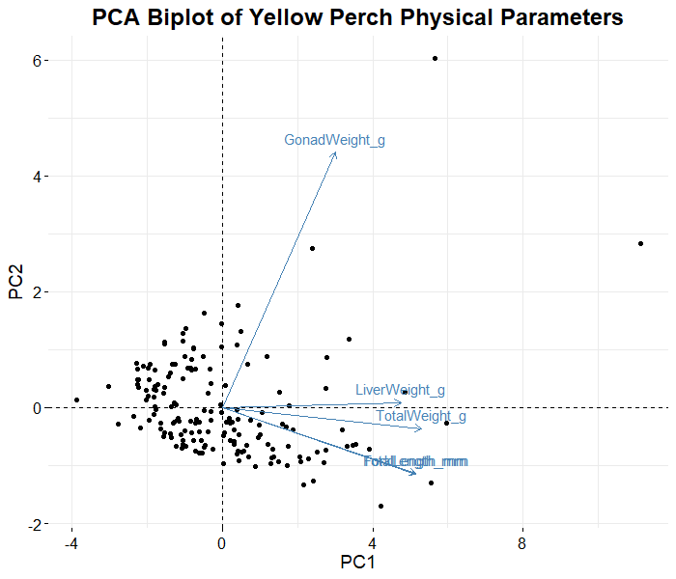

**Figure 3.** The PCA biplot using the Yellow Perch physical parameters (listed in Figure 2). Principal component 1 (PC1) explains 78.3% of the variability in the physical variables while principal component 2 (PC2) explains 15.4% of the variability. Physical parameters are indicated by the arrows. All parameters are positively associated with PC1. Gonad weight is most strongly, positively, associated with PC2.

For YP, the first principal component explains 78.3% of the variance, and the second principal component explains 15.4% of the variance (Appendix A: Figure A1). Total weight, total length, fork length, and liver weight each have a contribution of 20-25% to the first principal component. The first principal component will be used as a new variable that describes the size of the fish. In the second principal component, gonad weight has a contribution of 87.6%, whereas total and fork length each contribute 5.9%. Contributions of physical parameters for YP are located in Appendix A: Figure A3.

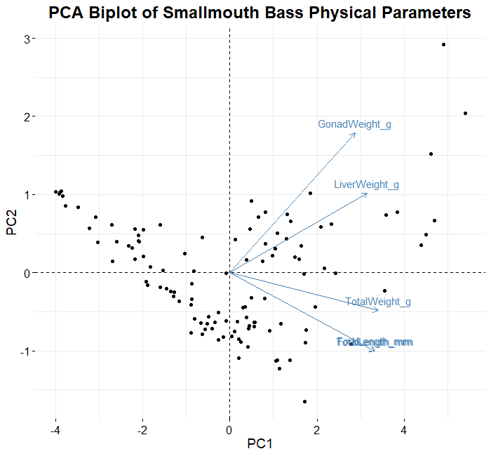

**Figure 4.** The PCA biplot using Smallmouth Bass physical parameters (listed in Figure 2). Principal component 1 (PC1) explains 85.2% of the variability in the physical parameters while principal component 2 (PC2) explains 10.6% of the variability. Physical parameters are indicated by the arrows. All parameters are positively associated with PC1. Gonad weight and liver weight are positively associated with PC2.

For SMB, the first principal component explains 78.3% of the variance, and the second principal component explains 15.4% of the variance (Appendix A: Figure A1). Total weight, total length, fork length, and liver weight each contribute between 19-22% to the first principal component, and gonad weight has a contribution of 15.9%. Again, this first principal component is a variable based on the size of the fish. In the second principal component, gonad weight has a contribution of 49.2%, and total length, fork length, and liver weight each have a contribution of 15-16%. Contributions of physical parameters for SMB are located in Appendix A: Figure A4.

### Developing a Linear mixed-effects model

log(Hg [μg kg-1 wet weight-1]) ~ PC1 + Sex + Site + (1|Date)

***(equation 1)***

Response:

**Hg (μg kg-1 wet weight-1 ):** The concentration of Hg in fish is the response variable of interest in this study. In aquatic ecosystems, Hg bioaccumulates with increasing fish size and trophic position. Furthermore, Hg is often elevated in sites upstream of dams. The wet weight of Hg will be used because this is the unit commonly reported in for consumption guidelines.

Fixed effects:

**PC1:** For each fish species, PC1 is a variable that summarizes the “size” of the fish (driven by fish length and weight). This is the main physical parameter which we are interested in as the predictor to test the hypothesis that Hg increases with increasing fish size.

**Sex:** Fixed effect as there are two sexes (male and female). The sexes may have different responses to Hg due to their relationship with PC1 or other biological differences between males and females.

**Site:** There are 3 sites, and we are interested in the difference between the sites - specifically, we want to investigate whether there is an increased slope in REF compared to NF or FF, due to potential increased Hg upstream of the dam.

Random effects:

**Date:** This is the date that each site was sampled in the field (n=12). Throughout the study, only one site was visited per sampling day. The sites were sampled on multiple dates, and each site was sampled a different number of times. Furthermore, any repeated visits to sites are not an important consideration for this study. By including the date as a random effect, we account for the distribution of effects for each date, although the dates themselves are not important.

#### Diagnostic plots

Diagnostic plots were completed for the linear mixed-effects model of each species to assess model assumptions (Appendix A: Figures A5-7). The diagnostic plots were used to compare models with and without log transformations of the predictor variable (Hg [μg kg-1 wet weight-1]). For both species, models with a log-transformation to the predictor variable were selected based on the improved residuals QQ plots after transformation. For both species, there were quantile deviations detected in the plots of residuals vs predicted values. These were identified as fish with large sizes (large values of PC1, as observed in Figure 2). These are datapoints with large predicted values and low residual values, which were underpredicted by the model. We reviewed these data points to check for data entry errors. The data were determined to be accurate and were kept in the model, and the model with the log-transformed predictor variable was selected for analysis.

### Results of the Linear mixed-effects model

We compared Hg concentrations between sites using our linear mixed effect model. We compared the Hg concentration between sites separately for each species due to the separate models. The differences in Hg concentrations between sites can be noted from the inferential plots and supported by the summary of the linear mixed effects model.

**Table 1.** Average values of Hg in μg kg-1 wet weight-1 of Yellow Perch and Smallmouth Bass.

|  |  |  |  |  |  |  |
| --- | --- | --- | --- | --- | --- | --- |
|  | All | REF | NF | FF | Male | Female |
| Yellow Perch | 309 | 346 | 254 | 332 | 304 | 314 |
| Smallmouth Bass | 569 | 412 | 693 | - | 569 | 567 |

**Table 2.** Results from the linear mixed-effects model of Yellow Perch. For sex, female is the intercept to which male is compared, and for site, REF is the intercept to which NF and FF are compared.

|  |  |  |  |  |
| --- | --- | --- | --- | --- |
|  | Estimate | Std. Error | t-value | p-value |
| Intercept | 5.59458 | 0.06019 | 92.955 | < 2 e-16 |
| PC1 | 0.09898 | 0.01604 | 6.171 | 5.75 e-09 |
| Sex – Male | 0.18217 | 0.06124 | 2.975 | 0.00341 |
| Site – NF | -0.21569 | 0.06581 | -3.277 | 0.00130 |
| Site – FF | 0.14389 | 0.06964 | 2.066 | 0.04048 |

**Table 3.** Results from the linear mixed-effects model of Smallmouth Bass. For sex, female is the intercept to which male is compared, and for site, REF is the intercept to which NF is compared.

|  |  |  |  |  |
| --- | --- | --- | --- | --- |
|  | Estimate | Std. Error | t-value | p-value |
| Intercept | 5.62783 | 0.11054 | 50.913 | 6.34 e-11 |
| PC1 | 0.16877 | 0.02535 | 6.658 | 2.74 e-09 |
| Sex – Male | 0.21230 | 0.09618 | 2.207 | 0.02965 |
| Site – NF | 0.80630 | 0.13296 | 4.40801 | 0.00271 |

Results from the linear mixed effect model outlined in equation 1 for YP are presented here. PC1 showed a positive relationship with log Hg concentration (Table 2; Figure 5; Figure A8). Furthermore, there was a difference in Hg concentration between the sexes, such that males had higher Hg than females (Table 2; Figure A8). However, the difference in Hg concentration between the sexes was not size adjusted, and even unadjusted, the difference between the raw means is only ~10 μg kg-1 wet weight-1 (Table 1). Although this was a statistical significance, the magnitude of the difference between sexes is not biologically meaningful and the difference is not a concern when considering the health risks associated with Hg consumption from fish. From the site effect plot for YP, it can be concluded that NF had the lowest Hg concentration while FF had the highest concentration, with REF falling in between (Figure A8). These differences in Hg concentrations between sites were supported by the summary of the linear mixed effects model as FF had a positive slope estimate compared to REF (increased from REF), while NF had a negative slope estimate compared to REF (decreased from REF) (Table 2). Furthermore, the site effects plot shows that the 95% confidence intervals of NF and FF do not overlap which suggests that the difference in Hg concentrations between these sites is greater than expected by chance (Figure A8).

Results from the linear mixed effect model outlined in equation 1 for SMB are presented here. PC1 showed a positive relationship with log Hg concentration (Table 3; Figure 6; Figure A9). Again, the sex effect plot shows that Hg is greater in males than females in SMB (Table 3; Figure A9). However, these concentrations are not size adjusted and the 95% confidence intervals have quite a large overlap (Figure A9). Furthermore, the raw difference in the means is only ~2 μg kg-1 wet weight-1(Table 1), which is not a biologically important difference in respect to risks of Hg consumption from fish. From the site effect plot for SMB, it can be concluded that NF had a higher Hg concentration than the REF site (Figure A9). Furthermore, this plot shows that the 95% confidence intervals do not overlap which suggests that the difference in Hg concentrations between these sites is greater than expected by chance. This is further supported by the summary of the linear mixed effects model as the slope estimate of NF compared to REF was positive and relatively high (~0.81; Table 3).

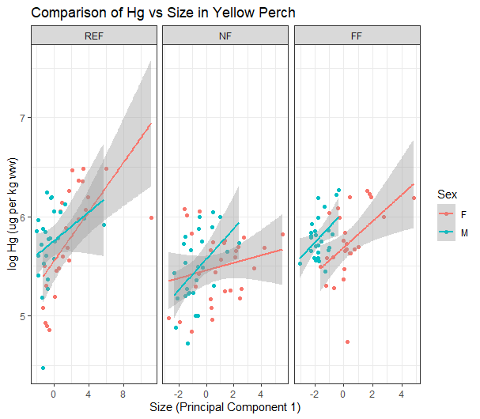

**Figure 5.** The linear relationship between fish size (Principal component 1) and log Hg concentration in Yellow Perch, compared between site and sex. Each point represents an individual fish. Fish in all sites have a positive relationship between size and log Hg concentration.

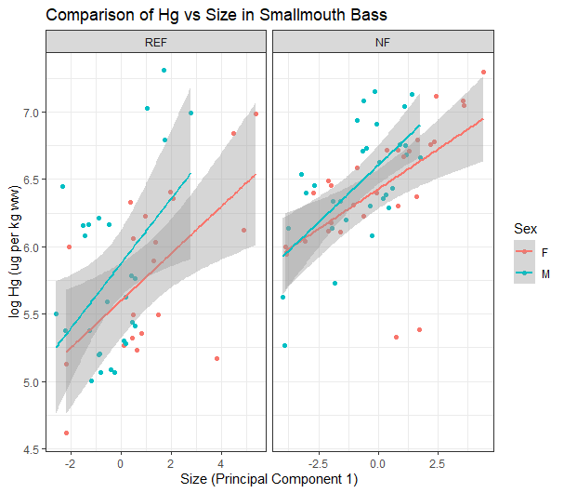

**Figure 6.** The linear relationship between fish size (Principal component 1) and log Hg concentration in Smallmouth Bass, compared between site and sex. Each point represents an individual fish. Fish in all sites have a positive relationship between size and log Hg concentration.

## Discussion

Using the PCA, we determined a parameter that summarized fish size (PC1), which was largely driven by total length, fork length and total weight. This was depicted in the screeplots of the PCA results, where PC1 explained 78% of the variance for YP and 85% of the variance for SMB. Furthermore, the results of the linear mixed effects model indicate that fish size was positively associated with Hg concentration in both SMB and YP, which demonstrates the risk of consuming larger fish.

In aquatic ecosystems, Hg concentrations increase with fish size. One factor affecting higher Hg concentrations in larger fish is that older, and by consequence larger, fish tend to feed on prey with higher Hg concentrations as they tend to have a higher trophic position (Trudel and Rasmussen 2006). Furthermore, these older fish, in general, have had a longer time to bioaccumulate Hg from the water and their food sources. Therefore, this size-dependent Hg accumulation in fish implies that larger fish are more contaminated and could pose a greater risk to consumers.

Although Hg concentrations are often seen to be higher upstream of dams in the reservoir, we did not find this trend in our results. For YP, Hg concentrations in fish from the site upstream were comparable to those found ~75 km downstream. Furthermore, in SMB, Hg concentrations in fish just downstream of the dam were higher than upstream.

The variability in Hg concentrations between sites may be caused by a number of factors. Although Hg tends to accumulate in reservoirs created by dams, fish from the REF site, upstream of the dam, were not the highest in Hg concentration for either species. This could be explained by the fact that this site was located farther upstream from the dam and was not directly located in the reservoir. Therefore, the impacts of Hg methylation by flooded soils may not have played as great of an influence. Furthermore, the Mactaquac Dam was constructed in 1965, and although previous studies have noted Hg increases in reservoirs up to 30 years after dam construction (Bodaly et al. 2007), the effects of Hg accumulation in fish may have leveled out since this dam’s construction. Interestingly, NF had the highest Hg concentrations in SMB yet the lowest in YP. This may be explained by differences in diet within the same species between the different sites, which may affect their trophic position between the two sites. Trophic position and basal food source of fish can be assessed using stable isotope ratios of δ15N and δ13C (Perkins et al. 2014), which is a method that will be used in the next steps of this study to explore the differences in Hg concentrations.

In future analyses, we could add the isotope ratios of δ15N and δ13C to the linear mixed effect model to determine the effect they have on Hg concentration. Furthermore, we could perform an ANCOVA comparing the relationship between the stable isotope ratios and Hg concentrations among the different sites. Then, we could see if there is a difference in the intercepts (e.g. is Hg concentration, with δ15N accounted for, higher at one site versus another?) and/or the slopes (e.g. does Hg concentration have a greater increase per value of δ15N at one site versus another?).

Finally, in the context of the overall project, a further step in this project would be to help local fishers evaluate the risk of Hg consumption in SMB and YP that are caught as food. The models in this report could be used to create a predictive model for SMB and YP using fish size parameters (total length, total weight) to determine fish Hg concentrations. This predictive model can determine the probability that SMB or YP with a certain length or weight will exceed the 500 μg Hg kg-1 wet weight-1 Canadian commercial consumption threshold based on the site which they were caught.

## Literature Cited

Bilodeau, F., R. Schetagne, J. Therrien, & R. Verdon. 2016. Absence of noticeable mercury effects on fish populations in boreal reservoirs despite threefold to sevenfold increases in mercury concentrations. *Canadian Journal of Fisheries and Aquatic Sciences 73*: 1104–1125.

Bodaly, R. A., W. A. Jansen, A. R. Majewski, R. J. P. Fudge, N. E. Strange, A. J. Derksen, & D. J. Green. 2007. Postimpoundment time course of increased mercury concentrations in fish in hydroelectric reservoirs of northern Manitoba, Canada. *Archives of Environmental Contamination and Toxicology 53*: 379–389.

Driscoll, C. T., R. P. Mason, H. M. Chan, D. J. Jacob, & N. Pirrone. 2013. Mercury as a global pollutant: Sources, pathways, and effects. *Environmental Science & Technology* *47*: 4967−4983.

Ouédraogo, O., J. Chételat, M. Amyot. 2015. Bioaccumulation and trophic transfer of mercury and selenium in African sub-tropical fluvial reservoirs food webs (Burkina Faso). *PLoS ONE 10*: e0123048.

Perkins, M. J., R. A. McDonald, & S. Bearhop. 2014. Application of nitrogen and carbon stable isotopes (ẟ15N and ẟ13C) to quantify food chain length and trophic structure. *PLoS ONE 9*: e93281.

Reinhart, B. L., K. A. Kidd, & R. A. Curry. 2018a. Preliminary report on mercury in fish above and below the Mactaquac Dam. *Mactaquac Aquatic Ecosystem Study Report* 2018-062.

Reinhart, B. L., K. A. Kidd, R. A. Curry, N. J. O'Driscoll, & S. A. Pavey. 2018b. Mercury bioaccumulation in aquatic biota along a salinity gradient in the Saint John River estuary. *Journal of Environmental Sciences 68*: 41-54.

Storelli, M. M., R. Giacominelli-Stuffler, & G. O. Marcotrigiano. 2006. Relationship between total mercury concentration and fish size in two pelagic fish species: Implications for consumer health. *Journal of Food Protection* *69*: 1402–1405.

Trudel, M., & J. B. Rasmussen. 2006. Bioenergetics and mercury dynamics in fish: A modelling perspective. *Canadian Journal of Fisheries and Aquatic Sciences* *63*: 1890–1902.

# **Appendix A: Supplementary Figures**

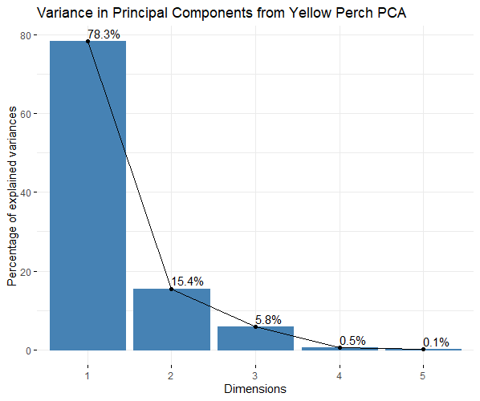

**Figure A1.** Screeplot from the PCA of the Yellow Perch physical parameters.

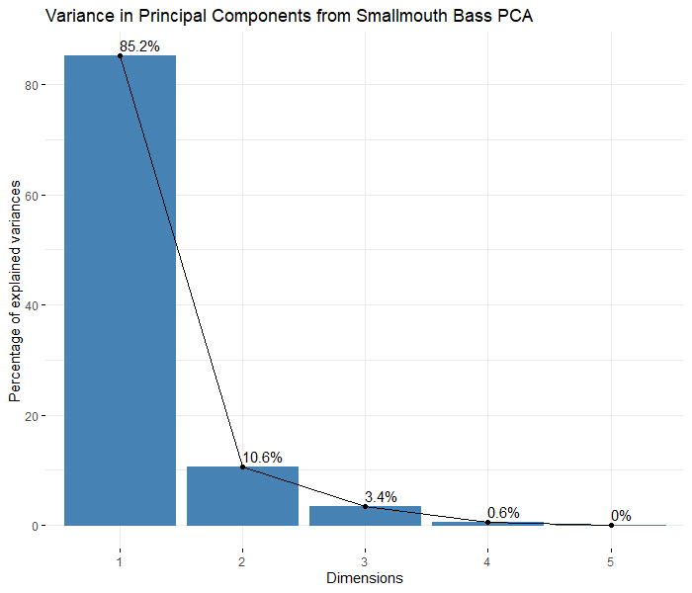

**Figure A2.** Screeplot from the PCA of the Smallmouth Bass physical parameters.

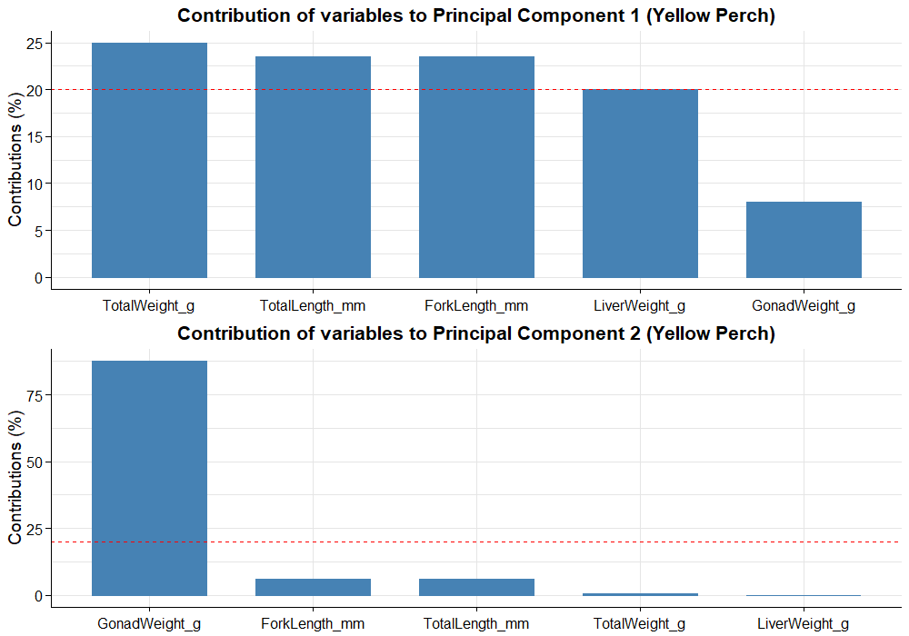

**Figure A3.** Contributions of variables to the first two Principal Components based on the PCA of the Yellow Perch physical parameters.

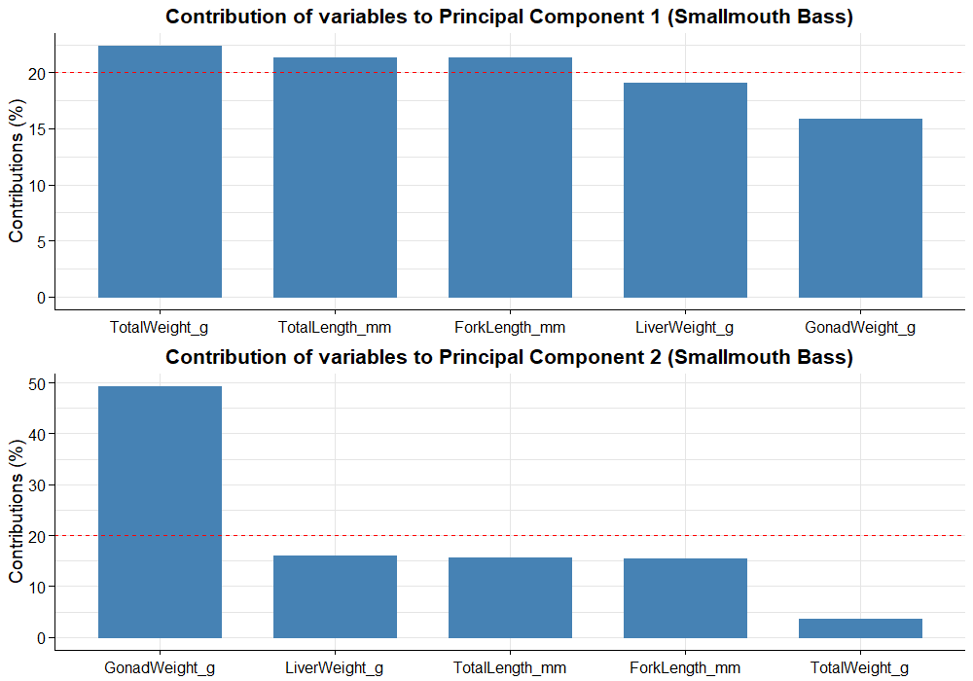

**Figure A4.** Contributions of variables to the first two Principal Components based on the PCA of the Yellow Perch physical parameters.

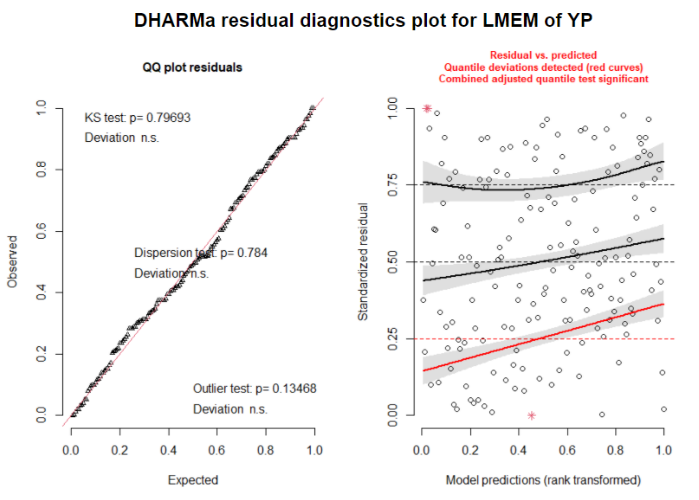

**Figure A5.** DHARMa simulated residuals diagnostic plots for the linear mixed-effects model of Yellow Perch outlined in equation 1.

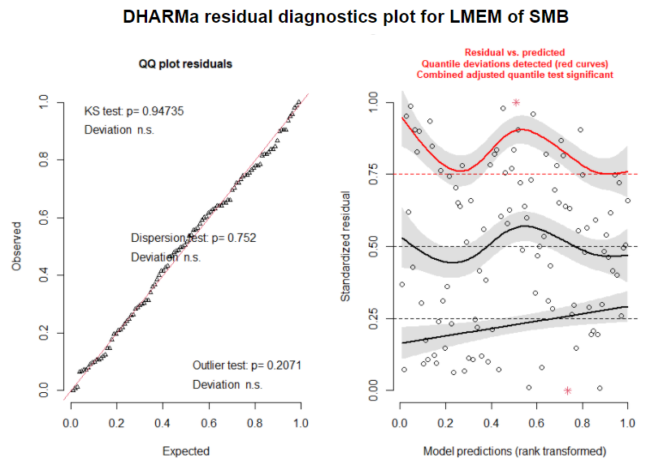

**Figure A6.** DHARMa simulated residuals diagnostic plots for the linear mixed-effects model of Smallmouth Bass outlined in equation 1.

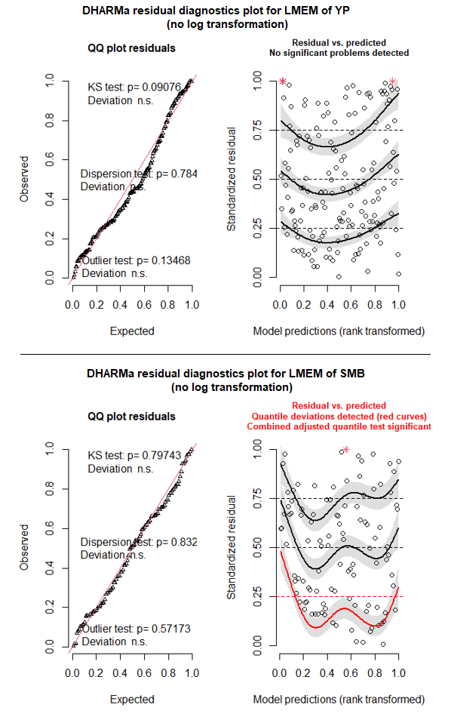

**Figure A7.** DHARMa simulated residuals diagnostic plots for the linear mixed-effects model of Yellow Perch (top) and Smallmouth Bass (bottom) without log transformation of Hg

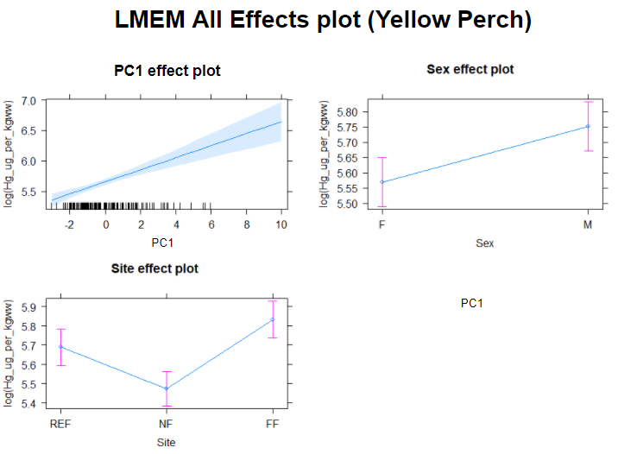

**Figure A8.** Effects plots of the linear mixed-effects model using equation 1 for Yellow Perch. Log Hg increases with size (PC1), males have greater Hg concentration than females and fish in FF have the highest Hg concentration followed by REF then NF.

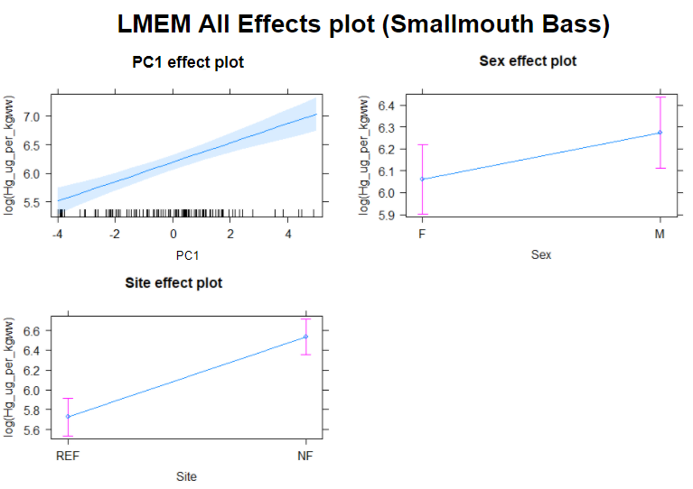

**Figure A9.** Effects plots of the linear mixed-effects model using equation 1 for Smallmouth Bass. Log Hg increases with size (PC1), males have greater Hg concentration than females and fish in NF have higher Hg concentration than in REF.